MIS 710 - Process Innovation and Management In-class Exercise: Organization of your firm
Name: Kaushik M Rao
Division: Solar City

The company's workforce is divided into four levels. All employees in the company are included in these tiers.
MANAGING DIRECTOR- The CEO oversees the company (Chief executing officer) of the business The company's CEO oversees all final executions.
MANAGEMENT- The management team is made up of all of the company's personnel. Marketing, IT, Finance, Public Relations, and other departments are examples. The management team is led by the vice president and the board of directors

GOUND STAFF- The ground staff is made up of people who oversee the ground operations. Shipping the solar cells and installing solar cells to the clients also providing support to the clients like repairs and maintenance.
HELPERS- These are the individuals who help in cleaning and maintaining the office facilities and inventory.

Sketch an Organization Chart showing your own organizational unit a box and, as far as you can, sketch the subordinate and superior organizational units?
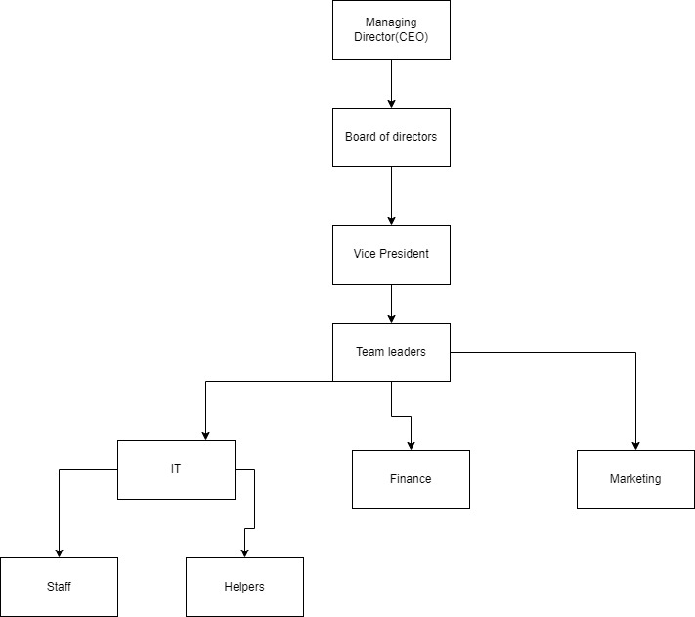

c. Has your firm developed a governance structure for major (core) lateral processes?
Answer: The employees that are selected for hiring are very selective. They go through rigorous screening process includes resume screening, telephone round interviews, live interview, they are also given a project which are expected to be delivered. The overall process takes around 5 months in order to complete. After getting hired employees are trained in the various technologies and expect to meet strict deadlines. They are expected to attend meetings regularly. They should come to the office onetime. Late arrivals results in penalty.

